The data contained in the file “tips1.xlsm” relates to the tip amount (in dollars) collected by a waiter, who worked on four days (Thursday, Friday, Saturday and Sunday). Let us assume that these four days were the only days on which the restaurant stays open. The data contains 244 observations in all. The data also contains information on the total bill amount, sex of the payer of the bill, whether the group of customers contained smokers, the rough time of the day (Lunch/ Dinner) and the size of the group of customers. We choose whether the group of customers contained smokers and sex of the payer of the bill, as the 2 factors. Based on these two factors we create an example of 2-way classified data, in which there are 15 observations in each cell, using the RANDBETWEEN function in Excel. The dependent variable is the tip amount paid. Given below is the mathematical model that we use:

$y_{ijk}=μ+α_{i}+β_{j}+γ_{ij}+e_{ijk},$*i=1,2*  *j=1,2* *k=1,2……,15*

where $\sum_{i}{α_{i}}=\sum_{j}{β_{j}}=0$, $\sum_{i}{γ_{ij}}=0$*for all j*, $\sum_{j}{γ_{ij}}=0$*for all i*.

*‘i’*  denotes the *ith* level of the factor gender of the payer of the bill.

*‘j’*  denotes the *jth* level of the factor whether the group of customers contained a smoker.

*yijk* denotes the *kth* observation for the *ith* level of the factor gender of the payer of the bill and the *jth* level of the factor whether the group of customers contained a smoker.

*µ* is a constant general effect present in all the observations.

*αi*= effect due to *ith* level of the factor gender of the payer of the bill.

*βj* = effect due to *jth* level of the factor whether the group of customers contained a smoker.

*γij*= interaction between the *ith* level of the factor gender of the payer of the bill and the *jth* level of the factor whether the group of customers contained a smoker.

*eijk* is the error. *eijk~NID(0,σe2)*

We intend to answer the following questions:

1. Whether the effects on the average tip amount, of the two levels of gender of payer of the bill, are equal?

2. Whether the effects on the average tip amount, of the two levels of the factor whether a group of customers contained a smoker or not, are equal?

3. Whether there is any interaction between the levels of the 2 factors gender of the payer of the bill and whether the group of customers contained smokers, in determining the average tip amount?

Below is given the plot of the tip amount for the 60 observations.

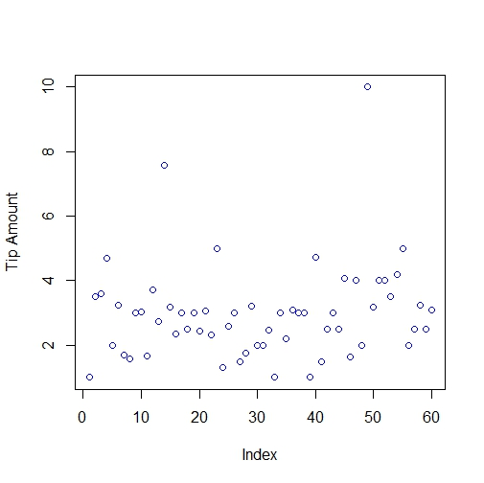

**Fig. 1**

Next, we give the boxplot of tip amount, grouped by gender and further subdivided into whether the party contained a smoker or not.

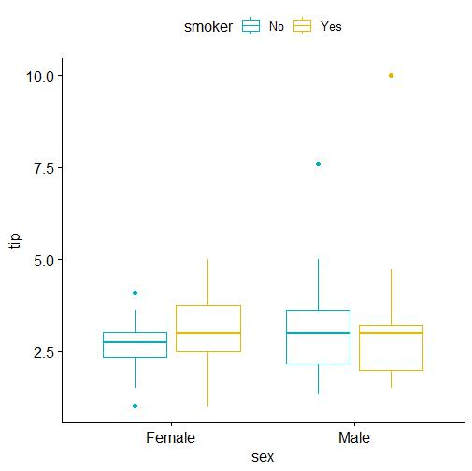

**Fig 2**

From the boxplot, we see that:

1. For a particular gender of the payer (say male), the average tip amount does not differ markedly between the scenario when the group of customers contained a smoker and the scenario when the group of customers did not contain a smoker.

2. For a particular scenario (say when the group of customers did not have a smoker), the average tip amount does not differ markedly with change in the gender of the payer.

We carry out ANOVA for 2-way classified data for fixed effects model, with equal number of observations per cell. We test the following null hypothesis (Ho):

1. The 2 factors are independent. (There is no interaction between the levels of the two factors, gender of the payer and presence of a smoker in the group of customers.)

*H01*: *γij=0* for all *i* and *j.*

2. The effects on the average tip amount of the 2 levels of gender, are equal.

*H02: α1=α2=0*

3. The effects on the average tip amount of the 2 levels of the factor, whether a smoker is present in the group of customers or not, are equal.

*H03: β1=β2=0*

For the test given in (1) above, the p-value comes as 0.720. So, we accept the null hypothesis of absence of interaction between the levels of the 2 factors, at 5% level. Since there is no interaction between the levels of the 2 factors, we can carry out the tests given in (2) and (3) above. The p-value for the test given in (2) above comes as 0.292. So, we accept the null hypothesis that the effects on the average tip amount of the 2 levels of gender, are equal, at 5% level. The p-value for the test given in (3) comes as 0.667. So, we accept the null hypothesis that there is no difference in the average tip amounts between groups that contain a smoker and groups that do not contain a smoker. The p-value for the Levene’s test for the sample comes as 0.4683. The p-value of the Shapiro-Wilk test for the above sample comes as 1.014e-06. So, normality does not hold for the sample observations. So, the results of the hypothesis testing may not be reliable.